

Motorola A810

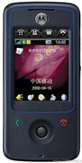
Description

With a large touch screen display and Motorola's advanced handwriting recognition, it's easy to communicate whether you are sending or receiving SMS or email. Text entry is as easy as using the stylus to write directly on the 2.2? interactive screen.

STORE PRICE: Rs 3,942 /-
ONLINE PRICE: Rs 4,327 /-

Brand : Motorola
Model Name : A 810
Released Year : 2008
Phone Memory : 8Shared Memory
External Memory : microSD (TransFlash), up to 2GB
Colors : Excellent Black and White Shang-chi
Form : Bar
Dimensions : 105 x 51 x 14 mm
Weight : 100 g

